**self-attention** = mechanism allowing model to focus on diff parts of the input

**Transformer**

input

→ tokenization (break into words/subwords…)

→ embedding (token to vector that captures the meaning)

→ positional encoding (adding position info with embedding info)

→ self-attention mechanism for each token in parallel

→ feed-forward neural networks

output

→ decoder (for sequence generation tasks)

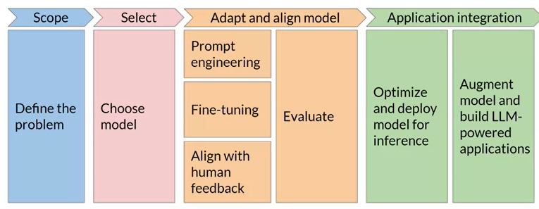

Select a Model

Encoder-only

for understanding/processing input sequence

ex. classification, token tagging, sequence labeling

ex. BERT (bidirectional encoder representation from transformers)

input sequence into context-rich output

uses bidirectional attention to capture context from **both sides** of each token

Decoder-only

for generating output sequence

ex. text generation, translation, completion

ex. GPT (Generative pretrained transformer)

output one token at a time using **unidirectional/causal attention** (only previous tokens)

used in language modeling and autoregressive text generation

Encoder-decoder

for tasks that require both understanding and generating sequences

ex. translation, summarization, sequence-to-sequence tasks

ex. T5 (Text-to-text transfer transformer), BART(bidirectional & auto-regressie transformer)

encoder generates context-rich representation

decoder uses encoder’s output and generate the output sequence

Prompt Engineering

ICL (in-context learning) - zero ~ five shot inference

works for small model

waste space in context window

Fine-Tuning

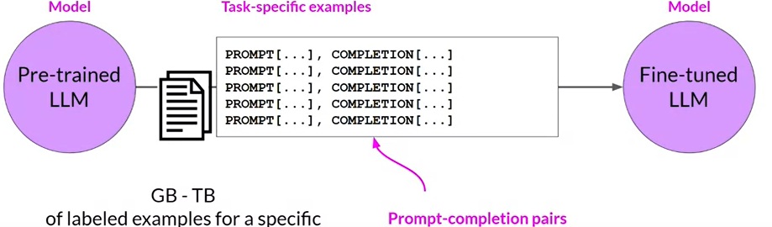

Type#1: Instruction fine-tuning: Fine-tuning a model to follow specific instructions better.

trains models using examples that demonstrate how to respond process

Type#2: Developer-specific fine-tuning: Fine-tuning for specialized applications.

Fine-Tuning Process #1 - Preparing Training Data:

Convert existing datasets into instruction prompt datasets using prompt template libraries. eg. Amazon reviews dataset

Fine-Tuning Process #2 - Training Process:

Divide the dataset into training, validation, and test splits

Challenges: **Catastrophic Forgetting**

Fine-tuning modifies the weights of the original LLM.

good on the fine-tuned task BUT bad on other tasks.

Method#1 - Assess Impact of forgetting on your desired LLM

Method#2 - **Multitask Fine-Tuning** to maintain multitask capabilities.

Uses a mixed dataset of tasks to get an instruction-tuned model capable of handling multiple tasks well.

ex: FLAN family of models (e.g., FLAN-T5 and FLAN-PALM).

FLAN models refer to a specific set of instructions used to perform instruction fine-tuning

Method#3 - **Parameter Efficient Fine-Tuning (PEFT):**

Preserves most of the original LLM weights and only trains a small number of task-specific adapter layers and parameters.

Greater robustness to catastrophic forgetting

Fine-Tuning Process #3 - Evaluation with holdout validation:

Measure performance using the holdout validation dataset to get validation accuracy.

hard to measure correctness with LLMs

Perform final performance evaluation using the holdout test dataset to get test accuracy.

LLM Metrics #1 - **ROUGE** (Recall-Oriented Understudy for Gisting Evaluation):

for summarization tasks.

Compares generated summaries and human references.

Metrics include

recall (match rate of reference words)

precision (match rate of generated words)

F1 score (harmonic mean of recall and precision).

ROUGE-1 considers single word(no order of words)

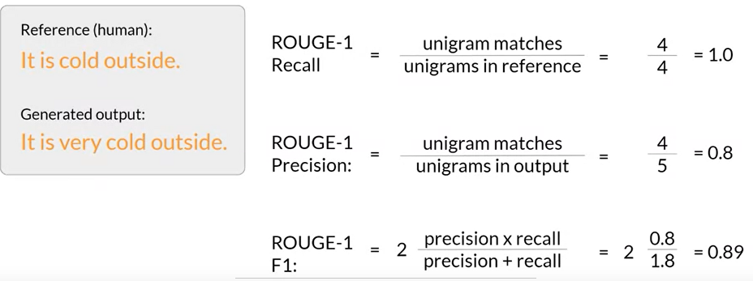

ROUGE-2 considers pairs of words

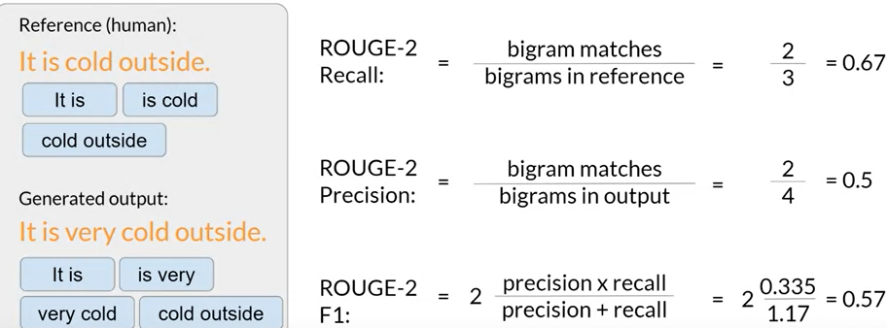

ROUGE-L focuses on the longest common subsequence

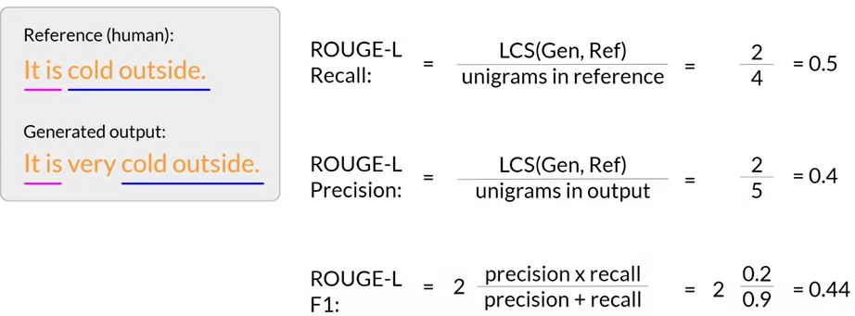

ROUGE clipping (bad completion but good score)

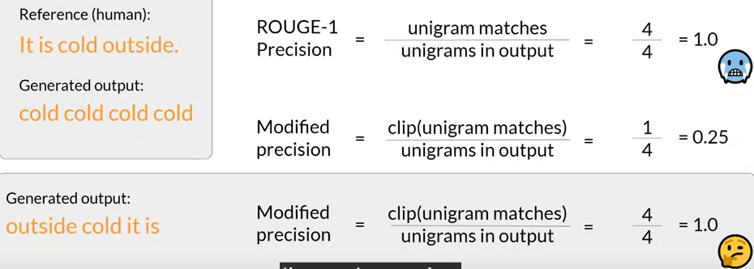

LLM Metrics #2 - **BLEU** (Bilingual Evaluation Understudy):

for translation tasks.

BLEU score indicates how closely the translation matches the reference.

Evaluates precision of generated text compared to the human translation.

Metrics = avg(precision across range of n-gram size)

Ex.

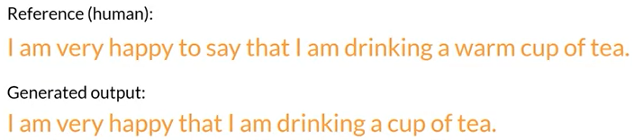

For overall model evaluation, comprehensive benchmarks are preferred.

GLUE (General Language Understanding Evaluation):

to evaluates models on a collection of natural language tasks like sentiment analysis, question-answering, and textual entailment.

SuperGLUE:

to addresses limitations of GLUE with more challenging tasks.

MMLU (Massive Multitask Language Understanding):

for modern LLMs to evaluate extensive world knowledge and problem-solving abilities across multiple domains

BIG-bench:

to provide a broad and challenging benchmark for evaluating LLMs on a wide array of tasks.

HELM (Holistic Evaluation of Language Models):

to improve transparency and provide guidance on model performance for specific tasks.

to ensure comprehensive evaluation, revealing trade-offs between different models and metrics.

**Parameter Efficient Fine-Tuning (PEFT)**

fine-tuning a smaller number of weights ⇒ smaller memory footprint

Trade-offs on parameter efficiency, memory efficiency, training speed, model quality, and inference costs

Methods #1 selective (subset of parameters)

Methods #2 **reparameterization** (reduce the number of parameters to train by creating new low-rank transformations of the original network weights)

eg. LoRA (Low-Rank Adaptation)

Methods #3 **Additive** (freezing original model weights or adding adaptive layers)

Adapter: add new trainable layers to the architecture of the model.

Typically placed inside the encoder or decoder components after the attention or feed-forward layers.

Purpose: Enhance model performance by introducing trainable layers without modifying the original model weights.

Soft Prompt: keep the model architecture fixed & manipulate the input.

Techniques:

Adding trainable parameters to the prompt embeddings.

Keeping the input fixed and retraining the embedding weights.

Purpose: Improve performance by adjusting how inputs are represented and processed by the model.

LoRA

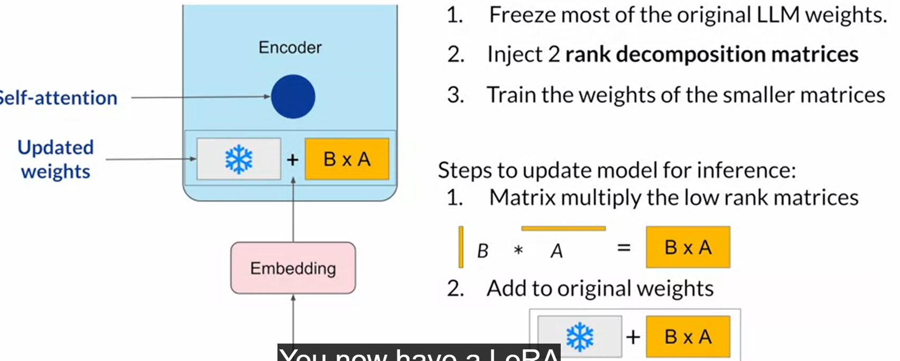Memory Efficiency: can often be performed with a single GPU

**Task-Specific Fine-Tuning**: fine-tune a different set for each task and switch them out at inference time.

Inference Latency: Little to no impact since the model has the same number of parameters as the original.

Soft prompt (prompt tuning)

Adds trainable tokens to prompts, leaving model weights frozen.

**Task-Specific Fine-Tuning**: able to switch also.

Prompting vs. Fine-Tuning

Developers often start with prompting for performance.

Fine-tuning with PEFT techniques is crucial when prompting hits a performance ceiling.

Cost Considerations

Full fine-tuning can be cost-prohibitive, making PEFT techniques more accessible.

The cost of using a giant model vs. fine-tuning a smaller model is a significant consideration for many developers.

Control over data and model size is important for applications needing in-house deployment.

Conclusion

Exciting developments and techniques in fine-tuning are making generative AI models more accessible and efficient.

The next video will focus on instruction fine-tuning.

Align with Human Feedback (Helpful + Honest + Harmless)

RL

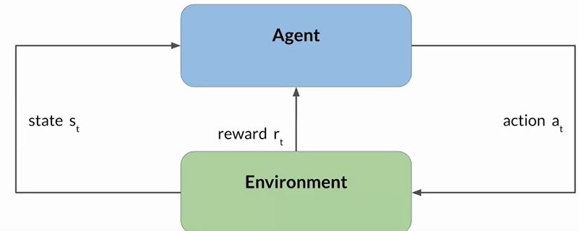

Actions lead to new states, and effective actions are rewarded.

LLM generates text (actions) based on a prompt (state).

Rewarded for outputs that align with human preferences (e.g., helpful, non-toxic).

Reward can be from human evaluation (expensive) or reward model (trained from human evaluation)

Human feedback

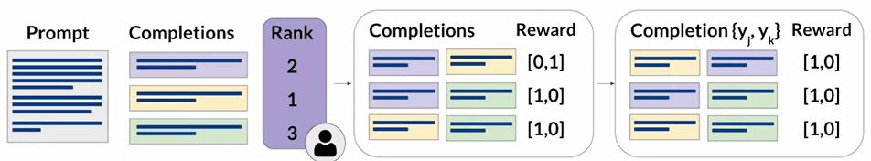

Convert ranking data into pairwise comparisons of completions.(N choose 2)

Make sure to reorder the pair so the preferred choice always comes first

Reward model

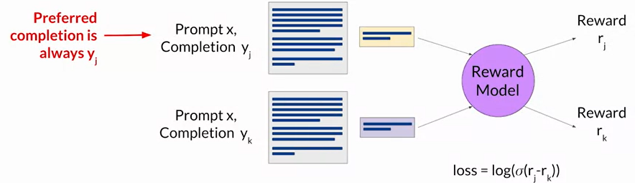

The reward model acts as a binary classifier.

**Reinforcement Learning from Human Feedback (RLHF)**

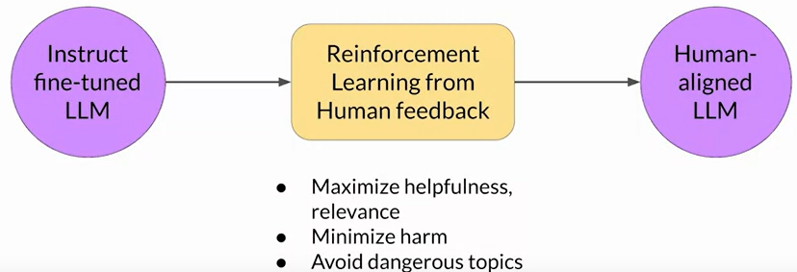

Aligns model outputs with human preferences.

Improves the usefulness, relevance, and safety of generated text.

Helps models acknowledge limitations and avoid harmful content.

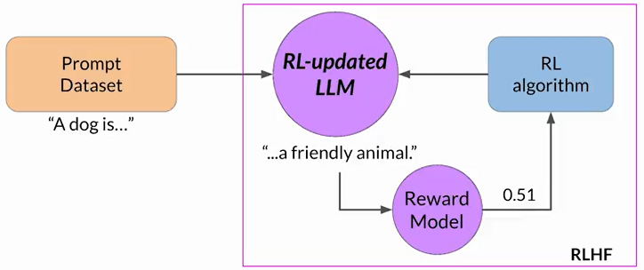

RL-updated LLM before 1st iteration = instruct fine-tuned LLM

RL-updated LLM after n iterations = human-aligned LLM

RL algorithm

to update the weights of the LLM, and move it towards generating more aligned, higher reward responses

ex. PPO(proximal policy optimization) is commonly used

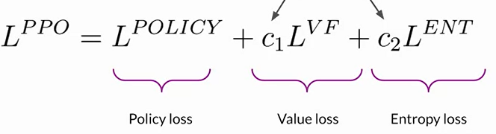

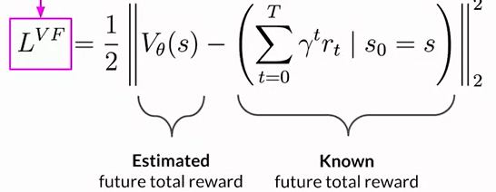



=min(reward from last state, reward from trust region)



higher entropy ⇒ higher creativity in completion

Potential problem: **reward hacking** (distort completion for higher reward)

avoid by keeping original/reference model fixed

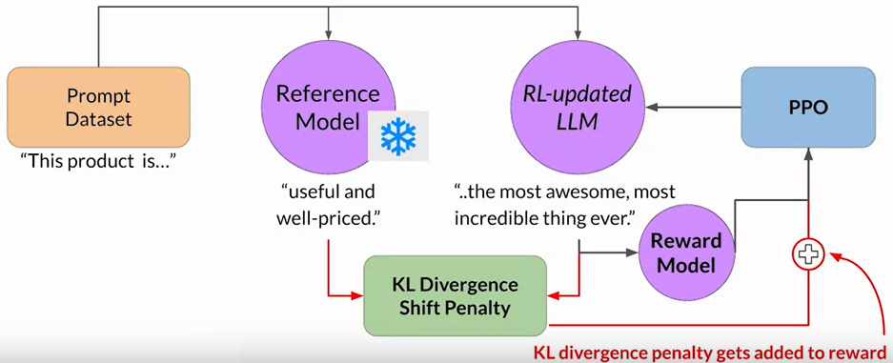

Replace RL-updated LLM by adding PEFT to save half of the memory

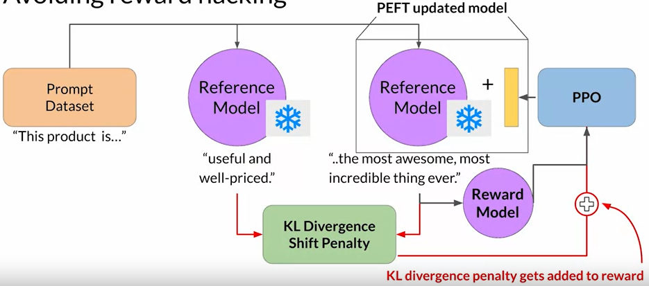

Scaling Human Feedback with Constitutional AI

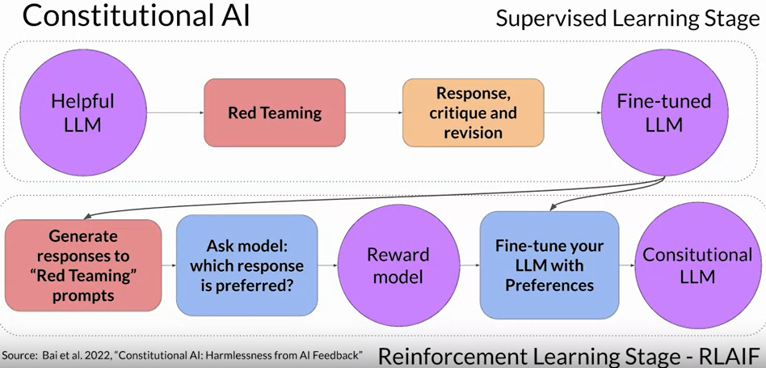

Supervised Learning Phase

Red Teaming (Generate harmful responses) → Self-Critique → Revision → Training Data (use pairs of red-team prompts and revised responses for fine-tuning)

RLAIF (Reinforcement Learning from AI Feedback)

Use model-generated feedback instead of human feedback.

ask the model to rank responses to train the reward model based on the constitutional principles.

PPO Fine-Tuning: Further refine the model with PPO based on the reward model’s feedback.

Deploy

3 ways to optimize model (save memory with similar performance)

Distillation: use a larger teacher model to train a smaller student model.

Student model mimics the teacher model’s behavior.

Freeze teacher model’s weights

Minimize the distillation loss with teacher’s probability distribution.

Apply a temperature parameter to the softmax function to soften the teacher model's output distribution.

Train the student model with standard softmax for hard predictions.

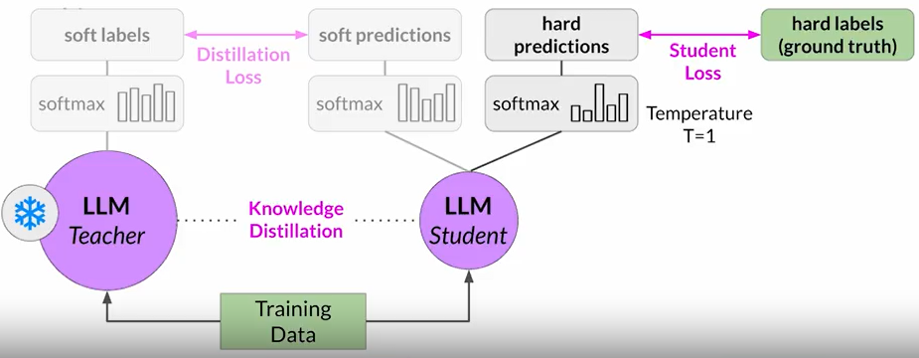

Quantization

Post-training quantization (PTQ) transforms model weights and/or activation layers to a lower precision representation.

Possible small percentage reduction in model evaluation metrics, balanced by cost savings and performance gains.

Pruning

Remove redundant weights that contribute little to model performance (weights close to zero).

Limitation: may have minimal impact due to fewredundant weights

Time/effort of lifecycle

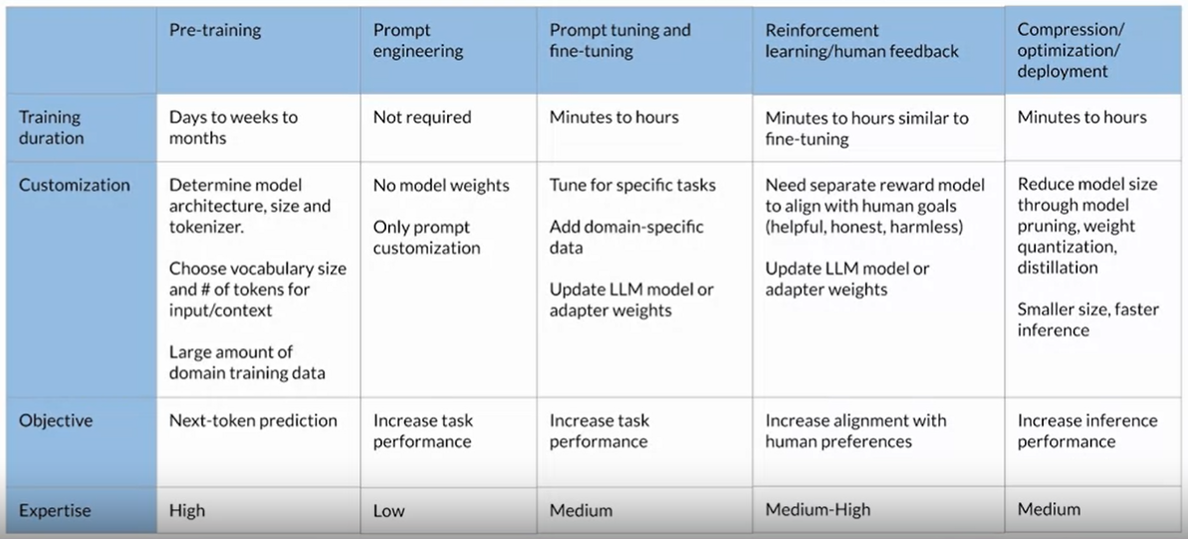

Issues after training

eg: Orchestration libraries like Langchain manage user input and model completions.

Issue #1: **knowledge cutoffs** ⇐ Retrieval Augmented Generation (**RAG**) by integrating external data

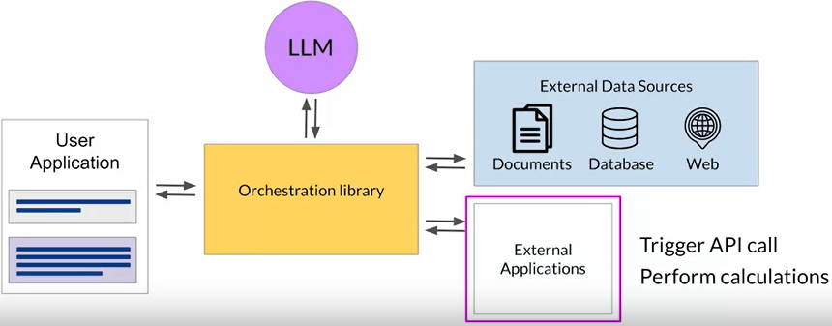

Increases relevance and accuracy without frequent retraining.

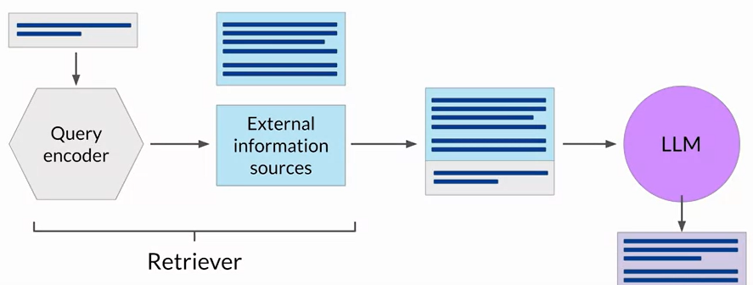

Advantages of RAG

Overcome Knowledge Cutoff: Provides access to up-to-date information.

Avoid Hallucination: Reduces incorrect information by using verified external sources.

External Information Sources (eg. vector stores for efficient searches)

Key Considerations #1:Context Window Size:

Challenge: External text often exceeds context window.

Solution: Split data into manageable chunks.

Key Considerations #2:Data Retrieval:

Requirement: Data formatted for easy retrieval.

Embedding Vectors: Facilitate fast and relevant searches.

Vector databases = vector store where each vector is also identified by a key

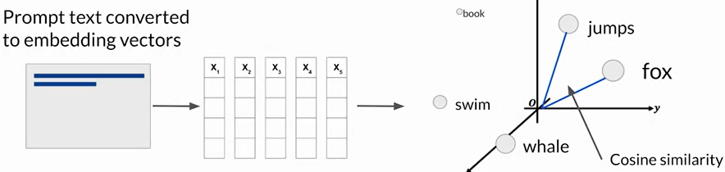

Issue #2: Complex Math ⇐ **Program-Aided Language (PAL), ReAct**

chain-of-thought can Improve reasoning by prompting the model to break down problems into intermediate steps, similar to human reasoning.

BUT still struggle with tasks requiring precise math.

PAL

Chain of Thought Prompting: The LLM generates Python scripts as part of its reasoning steps.

Execution: These scripts are executed by an interpreter to perform accurate calculations.

Issue #3: **Hallucination** ⇐ **ReAct**

question → thought → action → observation

action is predefined and triggered by thought

Setting Up ReAct Prompts

Instructions: Define task and allowable actions.

Example Prompt: Includes multiple thought-action-observation sequences.

Inference: Combine instructions, examples, and the new question for the LLM to process.

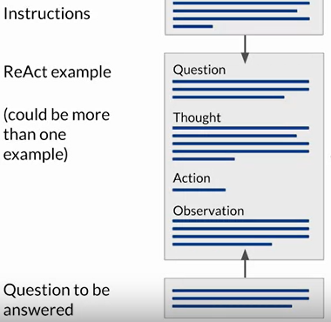

Langchain (support for PAL and ReAct agents)

